**Project Design Phase -2**

**Technical Architecture**

| Date | 06 October 2022 |
| --- | --- |
| Team ID | PNT2022TMID52526 |
| Project Name | Web Phishing Detection |
| Maximum Marks | 2 Marks |

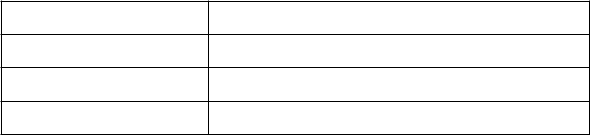

**Technical Architecture:**

